AWS S3 PROJECT

1. Introduction
Amazon Simple Storage Service (Amazon S3) is an AWS object storage service used to store and manage files such as documents, images, CSV files, backups, and application data. In this project, an S3 bucket is created and a file is uploaded into the bucket.

2. Project Objective
- Create an Amazon S3 bucket.
- Configure the basic bucket settings.
- Keep public access blocked for the bucket.
- Use the default server-side encryption setting.
- Upload a file into the S3 bucket.
- Verify that the uploaded file appears successfully in the bucket.

3. Requirements
- An AWS account.
- Internet connection and a web browser.
- A file to upload, for example a CSV file.
- Access to the Amazon S3 service in the AWS Management Console.

4. Step-by-Step Procedure

Step 1 – Open Amazon S3
Sign in to the AWS Management Console. Search for “S3” in the AWS services/search bar and open Amazon S3. From the S3 dashboard, select the option to create a bucket.

Step 2 – Configure General Bucket Settings
On the Create bucket page, select the AWS Region in which you want to create the bucket. Choose General purpose as the bucket type. Enter a globally unique bucket name, for example “my-s3-project-unique-name”. Bucket names must be unique within the applicable AWS namespace.
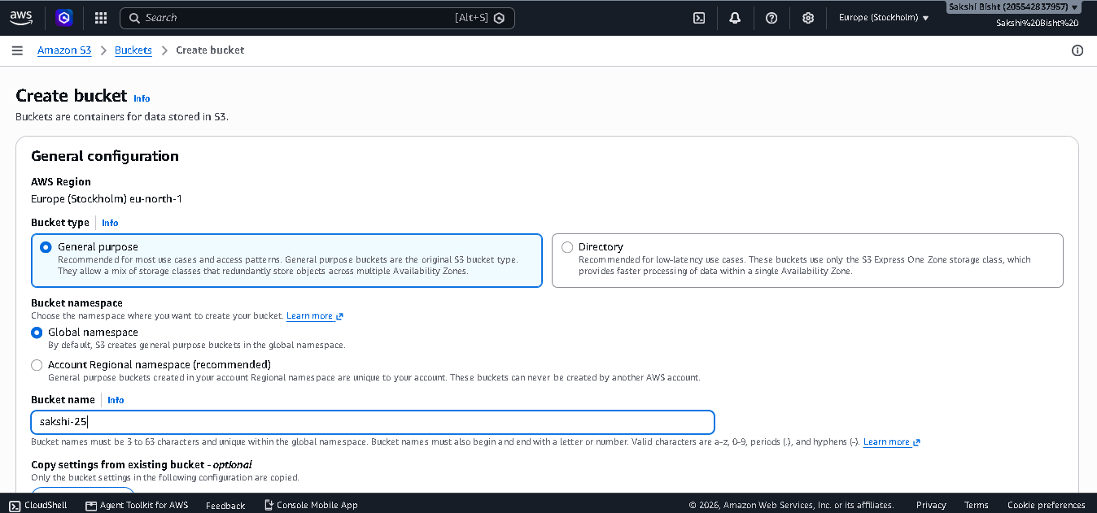

Step 3 – Set Object Ownership
In Object Ownership, keep the recommended ACL-disabled option selected. This allows access to objects to be managed through IAM policies and bucket policies instead of object ACLs.
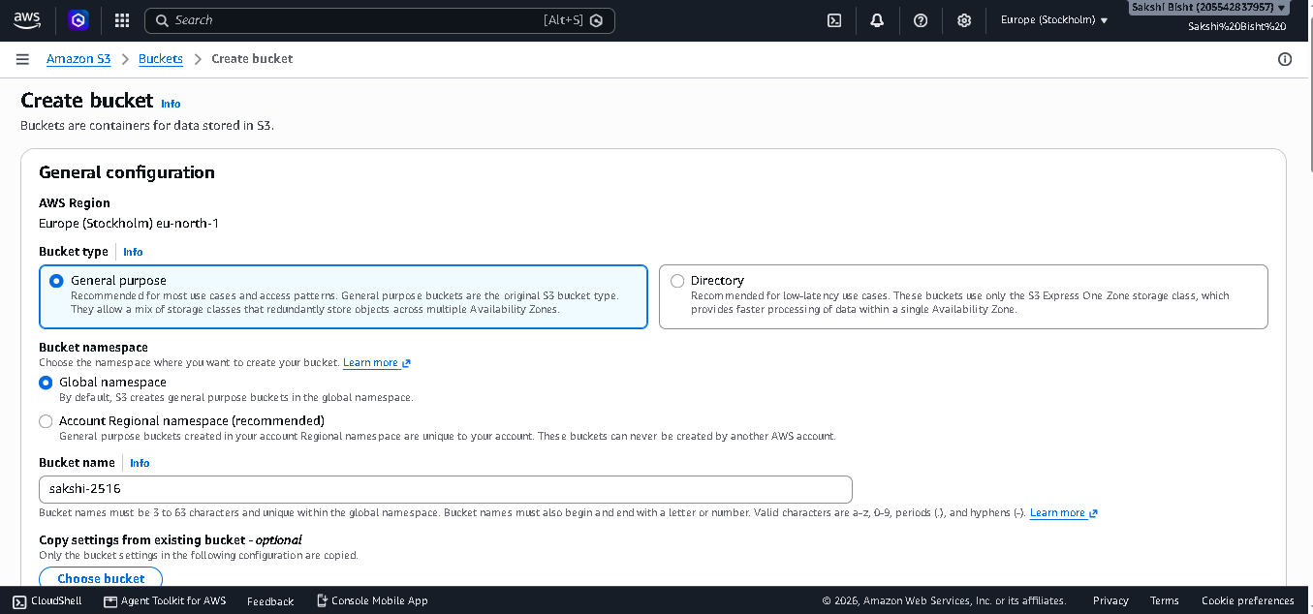

Step 4 – Configure Public Access
Keep “Block all public access” enabled unless your project specifically requires public access. For a basic storage project, blocking public access is the safer configuration.
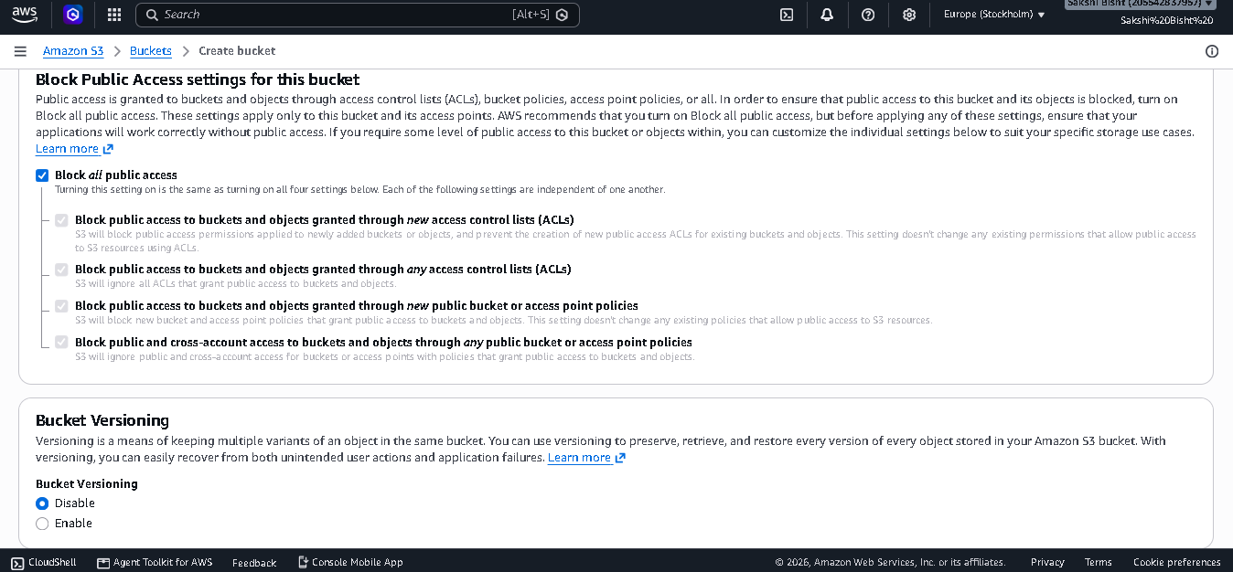

Step 5 – Configure Bucket Versioning
In Bucket Versioning, leave versioning disabled for this basic project unless you specifically need multiple versions of the same object.

Step 6 – Add Tags (Optional)
Tags can be added to organize AWS resources. For example, you can add Project = S3-Project. Tags are optional for this project.
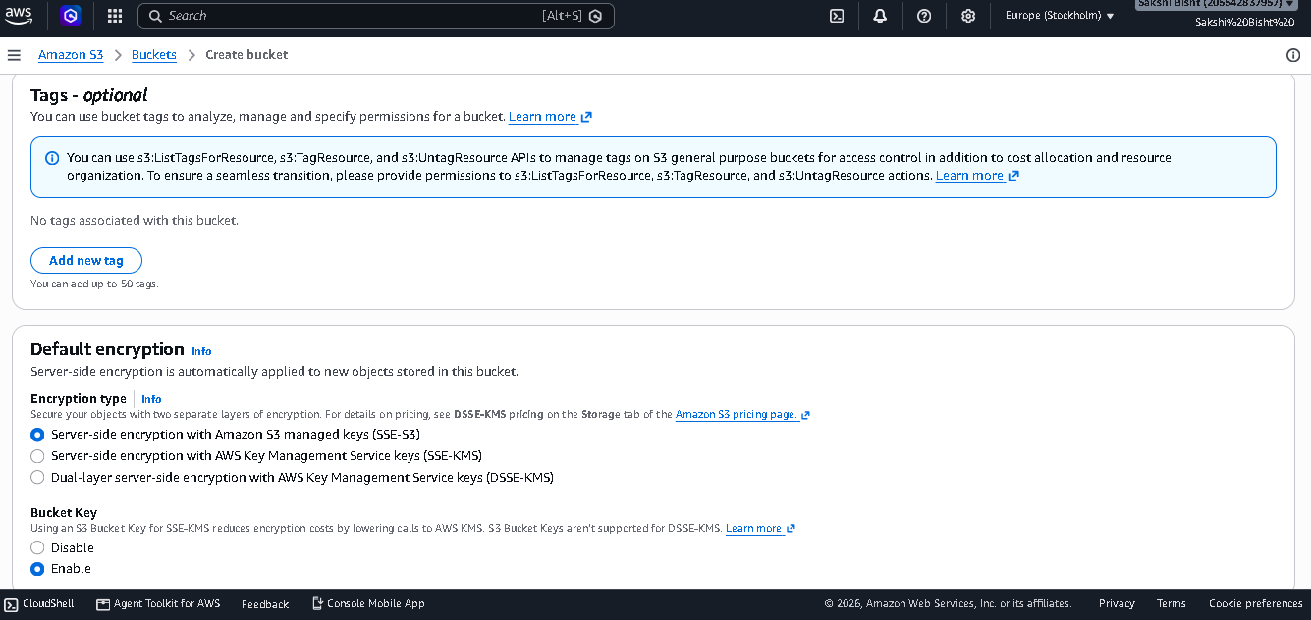

Step 7 – Configure Default Encryption
Keep server-side encryption enabled. The reference screenshots show the default server-side encryption configuration with Amazon S3 managed keys (SSE-S3). This provides encryption for objects stored in the bucket.
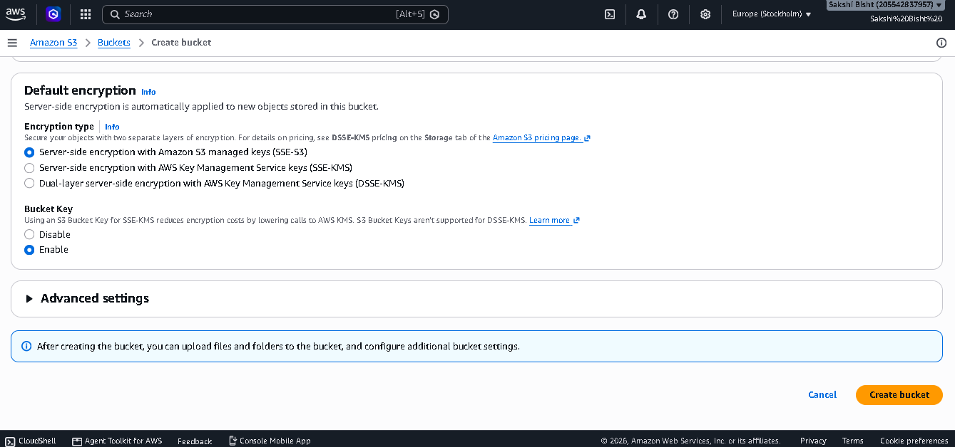

Step 8 – Create the Bucket
Review the configuration and select “Create bucket”. After successful creation, the new bucket will appear in the S3 bucket list.
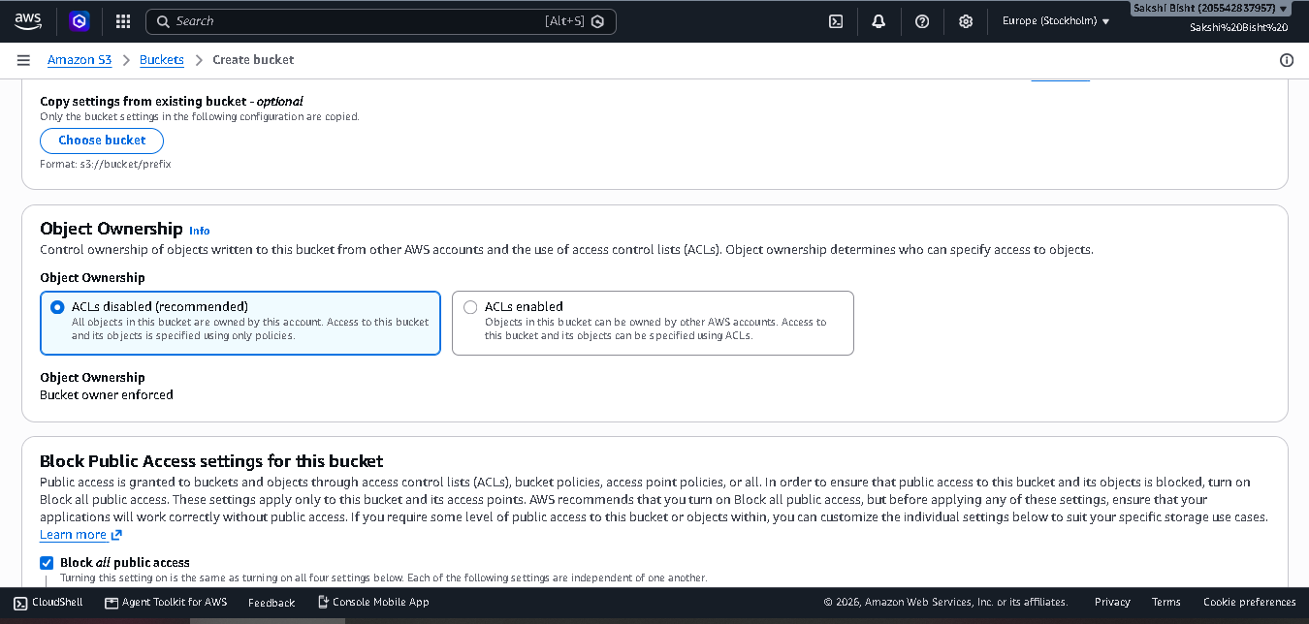

Step 9 – Open the Created Bucket
Select the newly created bucket from the bucket list. The bucket opens on the Objects tab. If it is a new bucket, the object list will normally be empty.
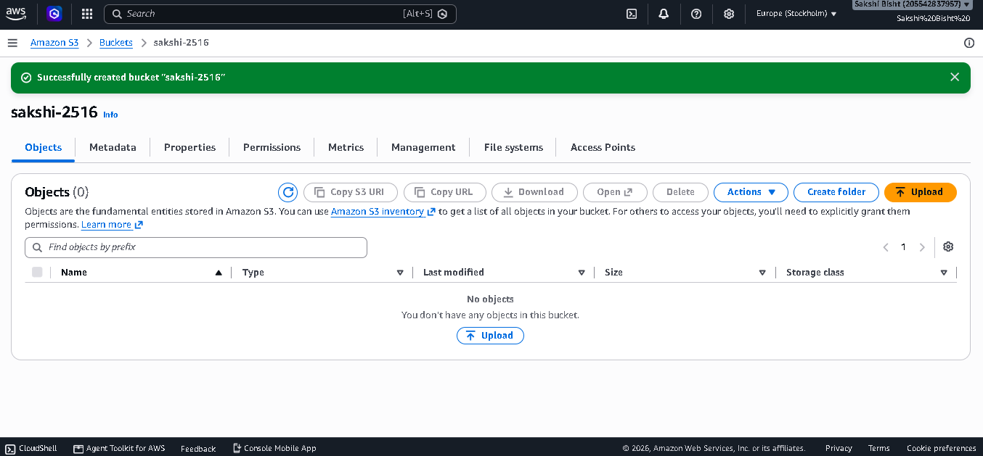

Step 10 – Upload a File
Inside the bucket, select “Upload”. Choose “Add files” or the corresponding upload option, select the file from your computer, and confirm the file appears in the upload list.
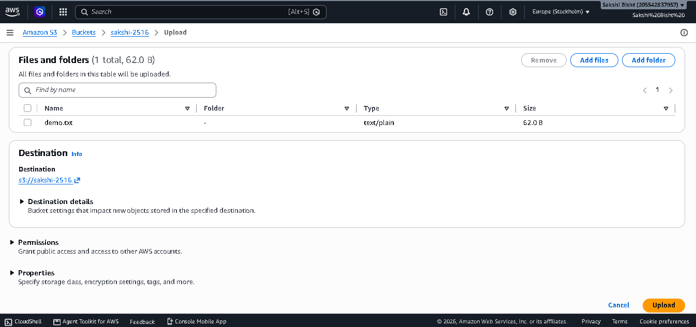

Step 11 – Complete the Upload
Review the selected file and choose “Upload”. Wait for the upload operation to finish. AWS will display an upload summary showing successful and failed files.
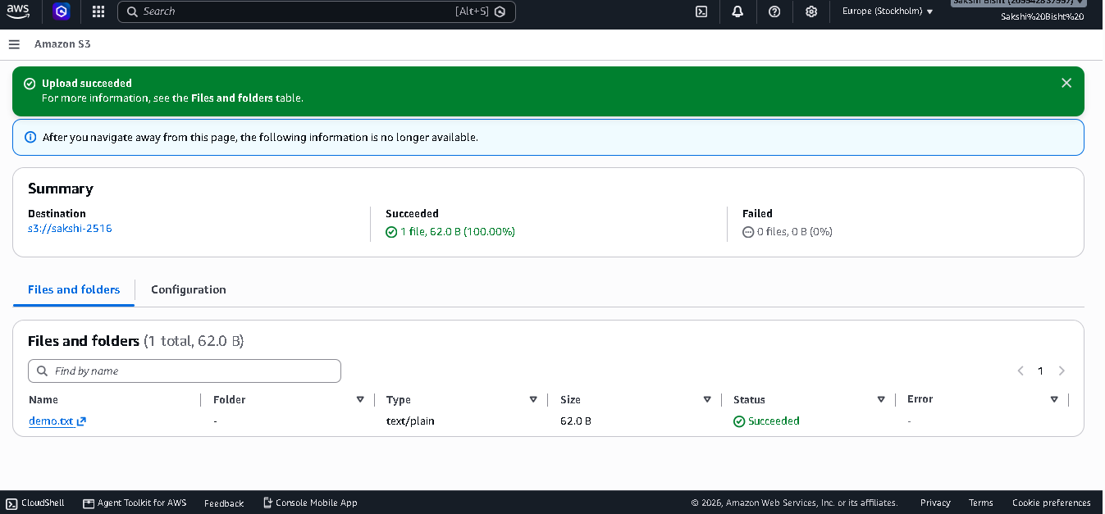

Step 12 – Verify the File
Return to the bucket's Objects tab. The uploaded file should now be listed with its object name, type, size, and other available metadata. This confirms that the S3 upload was successful.

5. Project Result
The S3 project is completed when the bucket is created successfully and the selected file is visible inside the bucket's Objects tab. The uploaded object can then be managed from the S3 console.

6. Conclusion
In this project, an Amazon S3 bucket was created using the AWS Management Console, basic security settings were configured, default encryption was retained, and a file was uploaded successfully. This demonstrates the basic workflow for storing objects in Amazon S3.

7. Important Notes
- S3 bucket names must be unique.
- Do not enable public access unless it is required for a specific use case.
- Avoid uploading sensitive or confidential data to a practice bucket.
- AWS charges can apply depending on storage, requests, data transfer, and other services used.
- Delete the practice bucket and its objects after the project if you no longer need them.

